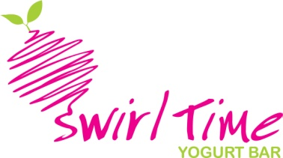

1718 East Cotati Ave. Rohnert Park, CA 94928

Welcome to Swirl Time, LLC

1. Disability Accommodation Available for Applicants.
If you require an accommodation for a disability so that you may participate in the selection process, you are encouraged to send correspondence to Swirl Time @ 1718 East Cotati Ave. Rohnert Park, CA 94928

2. Equal Opportunity / Affirmative Action Employer
Swirl Time, LLC is an Equal Opportunity / Affirmative Action Employer. Swirl Time, LLC is committed to diversity, inclusiveness and a welcoming environment for its staff. Consistent with their commitment, qualified individuals are consider for employment and employees are treated during employment without regard to any legally protected status including race, color, creed, religion, national origin, age, sex, marital status, disability, sexual orientation or veteran status.

3. Offer of Employment
Please be advised that Swirl Time, LLC will not be bound by offers or conditions of employment other than those made in official offer letters.

4. Application Fraud and Misrepresentation
I certify that all statements (verbal and written) made on any and all material collected during the hiring process are true, complete and accurate and I understand that misrepresentation or omission of facts called for in the employment application, resume, interview process or other application material may prohibit consideration at Swirl Time, LLC and is cause for immediate termination if employed.

5. Reference and Background Checks
Applying for a specific job authorizes Swirl Time, LLC to contact any of your schools, your current and former employers or other references for the purpose of verifying information and/or obtaining an account of your education, work experience and skills. By applying for a job you agree to hold any and all of your reference sources harmless and free of any liability for releasing such information. Please note that for some positions a more extensive background check is part of the
Employment decision making process and you will need to sign the necessary disclosure and release forms including, but not limited to a “Disclosure and Release of Information Authorization” form as part of the hiring process.

7. Employment Eligibility Verification
All offers of employment by Swirl Time, LLC are contingent on the provision of satisfying your identity and legal authority to work in the United States. Prior to or on your first day of employment, you must comply with the requirements of the Immigration and Naturalization Services’ Employment Eligibility Verification (I-9 Form).

8. Acknowledgement
I acknowledge that I have been informed of Swirl Time, LLC hiring policies. I understand that nothing contained in the hiring policies and practices constitute a guarantee of employment, and that my employment will be entirely at-will.
Date:
Print Name:
Signature:

